

American International University-Bangladesh (AIUB)
Department of Computer Science
Faculty of Science & Technology (FST)

PROJECT TITLE
MediAssist (AI-Powered Online Pharmacy System)
Semester: Spring 25-26

Group: 08 |  | Section: C
SL | Student Name | Student ID
1 | Mehedi Hasan | 22-48502-3
2 | Mst Maharuk | 23-52459-2
3 | RAFSAN TAHLIL RIFAT | 23-54948-3
4 | Zarin Anan | 23-55874-3

Table of contents

Table of contents 1
1. PROJECT PROPOSAL 2
2. Timeline Chart / Gantt Chart 4
3. SOFTWARE REQUIREMENTS SPECIFICATIONS (SRS) / PRODUCT REQUIREMENTS DOCUMENT (PRD) 5
3.1 Scopes and Features 5
3.2 User Story Table 6
3.3 Requirements Traceability Matrix 7
3.3.1 Functional Requirements 7
3.3.2 Non-Functional Requirements 8
4. SOFTWARE DESIGN 9
4.1 System Design: 9
• Use Case Diagram: 9
• Class Diagram: 10
4.2 UI / Wireframe Design using Figma 11
5. GIT WORKFLOW 14
6. SOFTWARE TESTING 16
7. CONCLUSION 19

PROJECT PROPOSAL
1.1 Background to the Problem/Problem Statement:
Accessing medicines and basic pharmaceutical advice is a basic need for health care. In many developed nations, this necessity becomes fulfilled progressively by digital pharmacy platforms which allow patients to order medicines online, communicate to pharmacists from a distance, and get it delivered to their door. But in Bangladesh, the pharmaceutical industry is still mostly offline, which makes it hard for millions of people to get the medicines they need safely and quickly.
Bangladesh has more than 170 million people, but a lot of them, especially those who live in rural and semi-urban areas, don't have easy access to qualified pharmacists or well-stocked pharmacies. Most pharmacies are in big cities like Dhaka and other divisional headquarters. However, even these city pharmacies don't always have all the medicines that people need, so they have to go to more than one store, and sometimes they can't find the medicine at all. Also, these city pharmacies are often too full, don't always have the right stock, and don't have any digital integration. Patients often go to more than one pharmacy to get the same medicine. This issue is much worse in rural areas, where there are few qualified pharmacists and pharmacies that have enough supplies. There is no reliable digital platform where a patient can describe their symptoms and get AI-assisted medicine suggestions before talking to a pharmacist. This is the most important thing. We often see a dangerous criteria where people get self-medication without professional guidance. In the absence of qualified pharmacist consultation, people in rural areas often take medicines based on their neighbors' advice, incomplete knowledge, or outdated prescriptions. As a result of wrong dosages, people get sick more often, and their health worsens.
The idea of creating Medi-Assist is to solve those problems directly. By creating a web-based platform that combines an AI-powered symptom checker with mandatory pharmacist verification, the system provides a safe, structured, and accessible path from symptom to medicine without requiring the patient to physically visit a pharmacy for every minor ailment. The AI handles initial guidance, the pharmacist handles verification, and the delivery person handles the delivery side. This three-layer model ensures both convenience and medical safety.
Now the question arises: why is this system needed at this moment, The demand for digital healthcare services in Bangladesh has improved significantly since the COVID-19 pandemic, which forced millions of people to seek remote alternatives for basic medical needs. Medi-Assist addresses this gap by improving the most common everyday healthcare interaction, buying medicine, and making it safer, faster, and more accessible through technology. It bridges the disconnect between patients and qualified pharmacists, particularly for those in rural and semi-urban areas who currently have no reliable way to verify medications, check stock availability, or receive professional guidance before making a purchase.

1.2 Selection of Process Model
We chose Scrum as the process model for developing MediAssist. Scrum is an Agile method that breaks the project into small parts and develops them step by step. These small work periods are called Sprints, and each Sprint usually lasts two weeks. At the end of every sprint, we get a working part of the system. This helps us see progress early, collect feedback, and improve the project quickly.
Scrum is a good fit for MediAssist because the system has many different modules, such as user login, AI symptom checker, chat with a pharmacist, order placement, payment, delivery tracking, and admin control. These features can be developed one by one in different sprints. This makes the work easier to manage and test.
Another reason we selected Scrum is that our project includes the AI symptom checker, which may need regular improvement based on testing and feedback. Scrum allows us to review the AI feature after each sprint and make changes if needed. This helps us improve the quality and safety of the suggestions.
Scrum also helps us get feedback from users and stakeholders early. For example, pharmacists, customers, and administrators can check the working features after each sprint and share their opinions. If something does not work well, we can fix it before moving to the next part.
This process model is also helpful for a small team like ours. Scrum gives everyone a clear role and keeps the team organized. We can meet regularly, discuss progress, solve problems quickly, and keep the project on track.

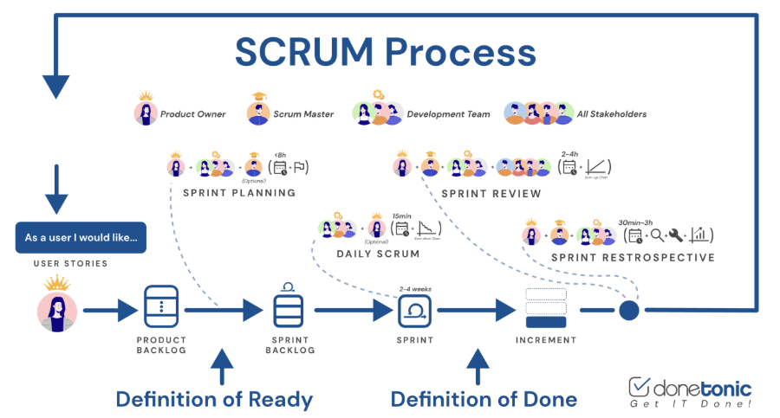

How Scrum works in our project
- Sprint 0: Planning
We collect all requirements, prepare tools, and decide what should be developed first.
- Sprint Planning
At the beginning of each sprint, we choose the features or user stories to complete.
- Daily Stand-up
The team shares daily progress, plans, and any problems in a short meeting.
- Development and Testing
We build and test the selected features during the sprint. Important features like payment and AI are tested carefully.
- Sprint Review
At the end of the sprint, we show the completed work to our supervisor or stakeholders and collect feedback.
- Sprint Retrospective
The team discusses what went well and what needs improvement for the next sprint.
- Repeat
We continue this cycle until all parts of MediAssist are completed and ready for use.

2. Timeline Chart / Gantt Chart
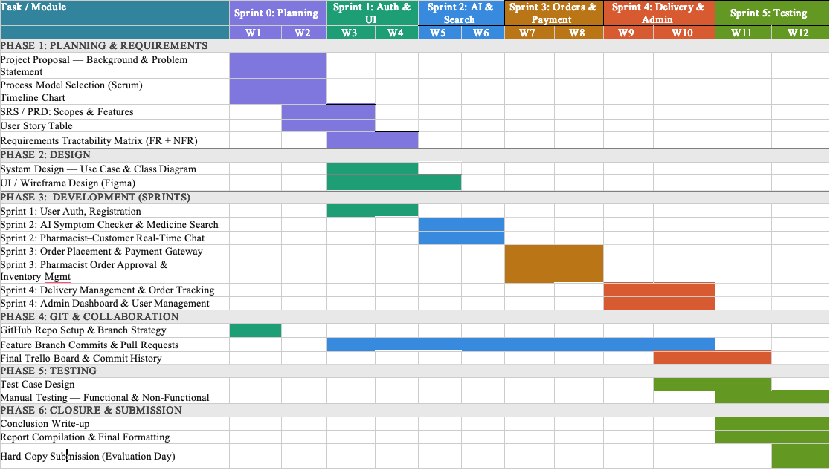

3. SOFTWARE REQUIREMENTS SPECIFICATIONS (SRS) / PRODUCT REQUIREMENTS DOCUMENT (PRD)

3.1 Scopes and Features
User Authentication: The system offers a uniform login method for all four user roles: customer, pharmacist, delivery person, and administrator. Before accessing any function, the system verifies identity via username and password. The system rejects any unauthorized or incorrect login attempts.
Role-Based Home Page: The system presents a distinct home page for each user role upon login. The customer's home page displays featured medicines, AI symptom checker entry, medicine search, and a direct chat option to consult a pharmacist. The pharmacist's home page displays incoming chat requests from customers, and inventory alerts. The delivery person's home page displays assigned orders and delivery status updates. The administrator's home page displays system statistics, pending complaints, and activity alerts.
User Registration: The system allows new customers to create an account by providing required personal details. The system validates the submitted information and creates a verified account. Then customers can order and use the Ai chat bot and chat with the pharmacist.
Medicine Search: The system allows customers to search for medicines by name or category. The system returns matching results from the medicine catalog.
AI Symptom Checker: The system provides an AI-powered symptom checker that takes symptom input from the customer and generates medicine suggestions.
Direct Customer–Pharmacist Chat: The system provides a real-time chat feature that allows customers to directly consult an available pharmacist before or after placing an order. The pharmacist receives the chat request on their home page dashboard and responds to the platform.
Order Placement & Payment: The system allows customers to place medicine orders. Payment is completed at the time of order placement by card, mobile banking, or cash on delivery. The system generates an order confirmation upon successful payment.
Pharmacist Order & Inventory Management: The pharmacist confirms or cancels customer orders from the dashboard. The pharmacist may attach usage notes to approved orders before dispatching. The pharmacist manages inventory, sees low-stock, and requests refill.
Delivery Management: The system assigns confirmed orders to delivery personnel. The delivery person views assigned orders with customer address and contact details, updates delivery status at each stage, and marks the order complete upon handover. Failed attempts are reported, and the system flags the order for rescheduling.
Order Tracking: The system provides customers with real-time delivery tracking. Status changes trigger automatic notifications to the customer at each stage of the delivery process.
Administrator User Management: The administrator manages all user accounts by creating, suspending, and removing accounts as needed. The system automatically sends suspicious activity alerts upon detecting abnormal patterns. The administrator handles complaints and generates system reports covering orders, and AI accuracy.
3.2 User Story Table
SL NO. | Module | Screen Definition | User Story
1 | USER REGISTRATION | Name (mandatory),  Email (mandatory),  Password (mandatory),  DOB (mandatory),  Phone (mandatory),  Button = Register | As a new user, I want to create an account to access the platform.
2 | LOGIN | Email (mandatory),  Password (mandatory);  Buttons = Login, Forgot Password | As a registered user, I want to log in securely to access my dashboard.
3 | CUSTOMER DASHBOARD (AI & SEARCH) | Search Bar, AI Chat,  Medicine Catalog Grid,  Chat with Pharmacist,  Cart, Buy, Login | As a customer, I want to search medicines, get AI symptom suggestions, and consult a pharmacist.
4 | PHARMACIST DASHBOARD | Incoming Chat Requests, Pending Orders List,  Inventory Panel,  Order Verification Buttons (Approve/Reject) | As a pharmacist, I want to verify prescriptions, approve orders, and answer customer queries.
5 | ORDER PLACEMENT & PAYMENT | Order Summary,  Payment Method Selection (Card/Mobile Banking/COD), Prescription Upload (if required),  Confirm Button | As a customer, I want to place an order and complete payment securely.
6 | DELIVERY PERSON DASHBOARD | Assigned Orders List,  Customer Address/Contact, Status Update Dropdown,  Mark Complete Button | As a delivery person, I want to view assigned orders, update delivery status, and complete deliveries.
7 | ORDER TRACKING & NOTIFICATIONS | Tracking Timeline,  Live Status Indicator, Notification Log,  Contact Delivery Button | As a customer, I want to track my order in real time and receive status updates.
8 | ADMIN DASHBOARD | Inventory,  Report,  Database,  Chat,  Add user,  Settings | As an admin, I want to manage users, monitor system health, and handle complaints.

3.3 Requirements Traceability Matrix

3.3.1 Functional Requirements
Req ID | Requirement Description | Design Module | Code Module | Test Case ID
FR-01 | User/Customer Registration | Auth & User/Customer Management | register.py | TC-FR01
FR-02 | Secure Login & Role-Based Routing | Auth & Session Management | login.py | TC-FR02
FR-03 | AI Symptom Input & Suggestion Generation | AI Integration Module | symptom_checker.py | TC-FR03
FR-04 | Medicine Search & Catalog Filtering | Inventory & Search UI | search/catalog.py | TC-FR04
FR-05 | Real-Time Customer-Pharmacist Chat | Web Chat Module | chat.py | TC-FR05
FR-06 | Order Placement & Prescription Validation | Order Processing | create_order.py | TC-FR06
FR-07 | Payment Gateway Integration | Payment Module | payment.py | TC-FR07
FR-08 | Pharmacist Order Approval & Inventory Update | Order & Inventory Management | pharmacist/order_mgr.py | TC-FR08
FR-09 | Delivery Assignment & Status Tracking | Logistics & Routing | delivery/tracker.py | TC-FR09
FR-10 | Admin User & Inventory Management & Report Generation | Admin portal | admin/portal.py | TC-FR10

3.3.2 Non-Functional Requirements
Req ID | Requirement Description | Design Module | Code Module | Test Case ID
NFR-01 | System Response Time ≤ 2s | Performance Architecture | middleware/perf_opt.py | TC-NFR01
NFR-02 | Data Encryption & Secure Authentication | Security Layer | security/crypto.py | TC-NFR02
NFR-03 | Role-Based Access Control (RBAC) | Authorization Module | auth/rbac.py | TC-NFR03
NFR-04 | Database Normalization & 24hr Backup | Data Architecture | db/backup_scheduler.py | TC-NFR04
NFR-05 | System Uptime ≥ 99% & Error Recovery | Infrastructure & Monitoring | infra/health_check.py | TC-NFR05
NFR-06 | AI Disclaimer & Compliance Validation | AI Governance Module | ai/compliance_checker.py | TC-NFR06
NFR-07 | Intuitive UI & Accessibility Standards | Frontend Design | ui/components.py | TC-NFR07
NFR-08 | Auto-Refresh & Pagination Optimization | Performance Optimization | utils/pagination.py | TC-NFR08

4. SOFTWARE DESIGN

4.1 System Design:

Use Case Diagram:
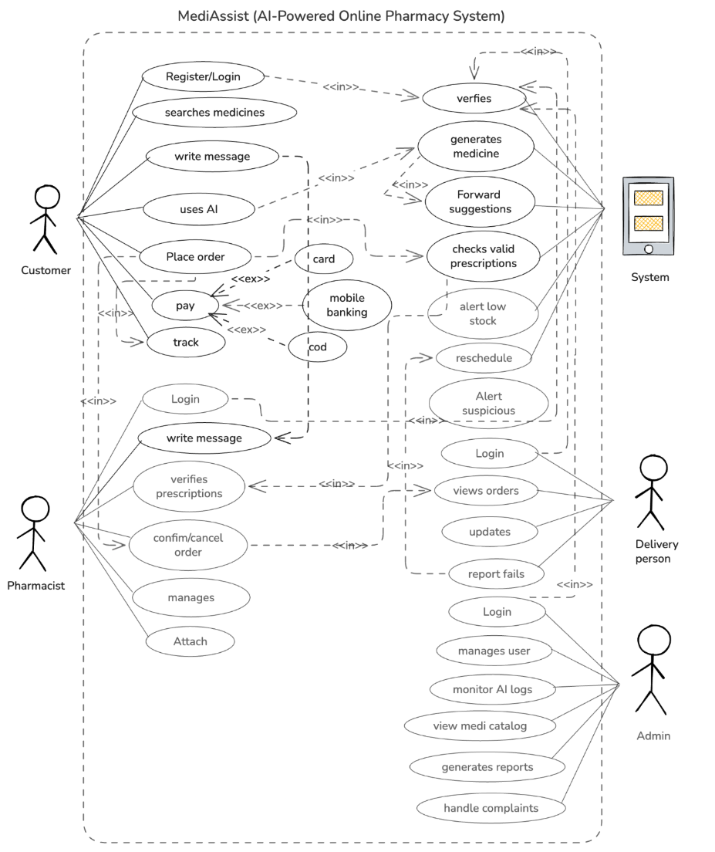

Class Diagram:
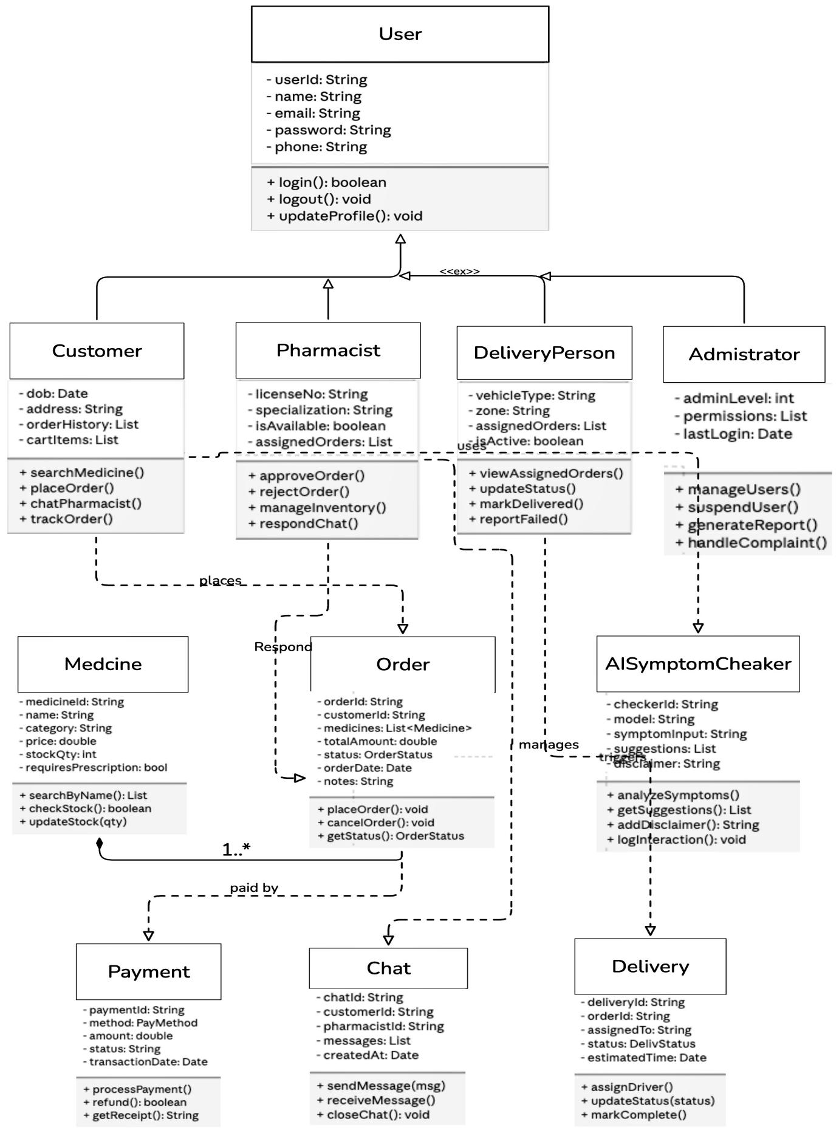

UI / Wireframe Design using Figma
- Customer UI:
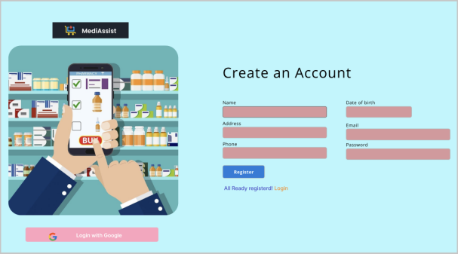  Fig 4.2.1 Customer registration | 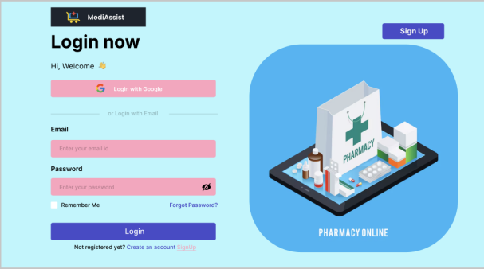  Fig 4.2.2 Customer login
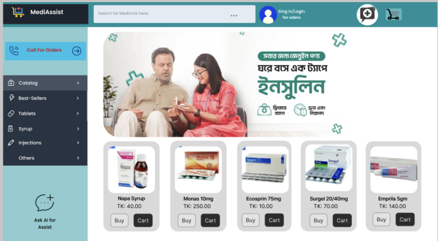  Fig 4.2.3 Catalog | 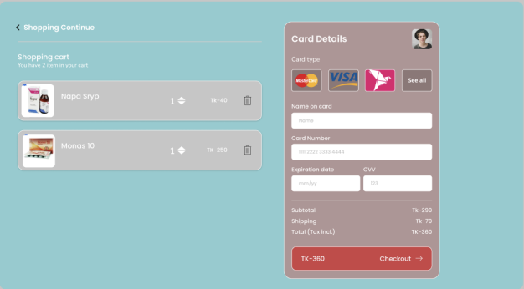  Fig 4.2.4 Cart & Payment
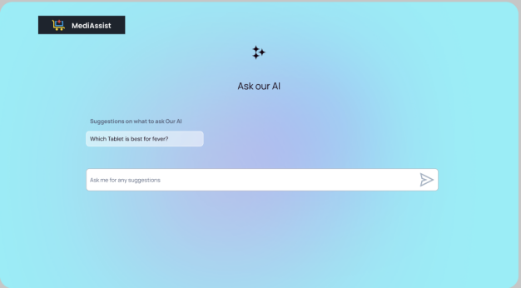  Fig 4.2.5 AI chat | 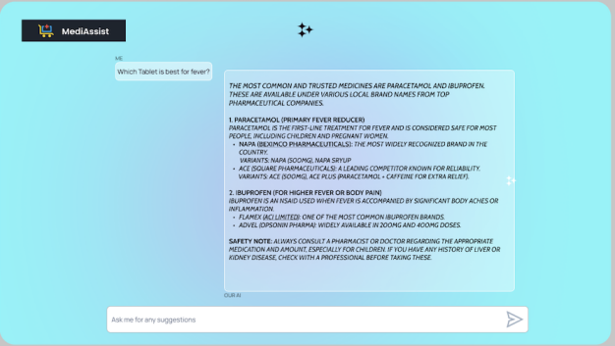  Fig 4.2.5 AI chat
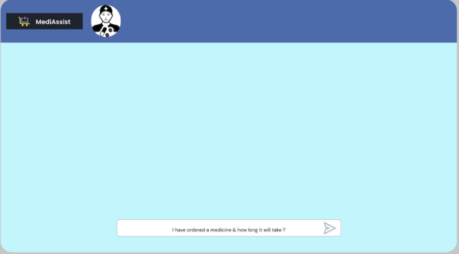  Fig 4.2.6 Customer-Pharmacist Chat | 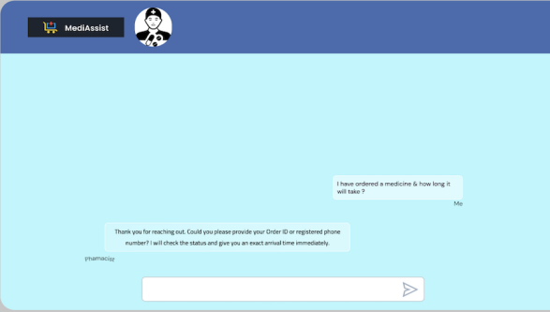  Fig 4.2.6 Customer-Pharmacist Chat

- Admin UI:
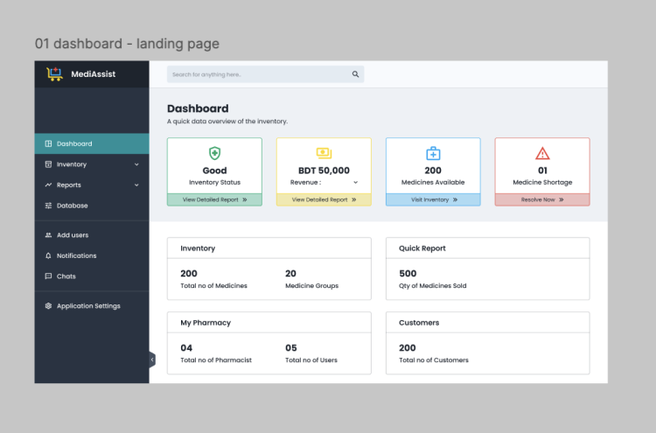  Fig 4.2.7 Admin Dashbord | 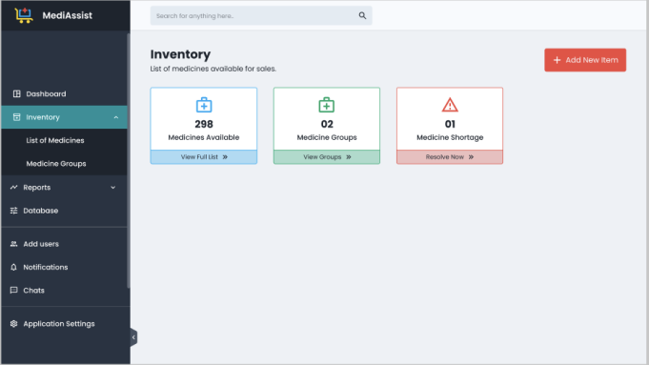Fig 4.2.8 Inventory
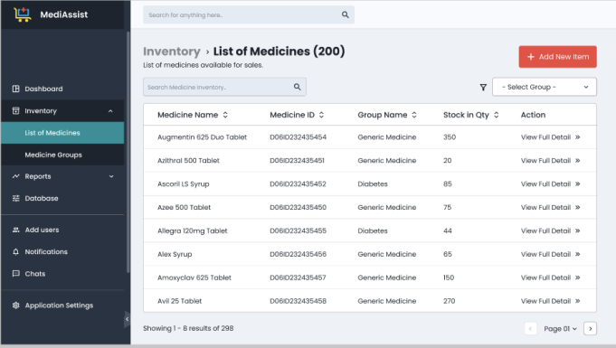Fig 4.2.9 Inventory (List of Medicine) | 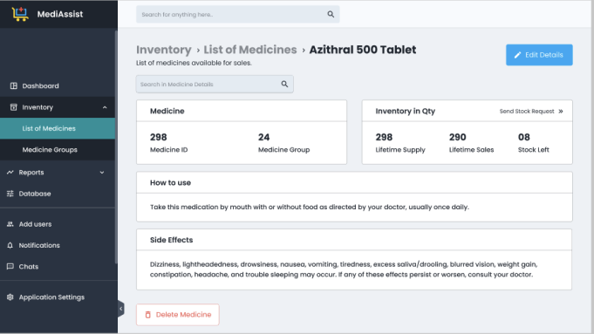Fig 4.2.10 Inventory (List of Medicine)
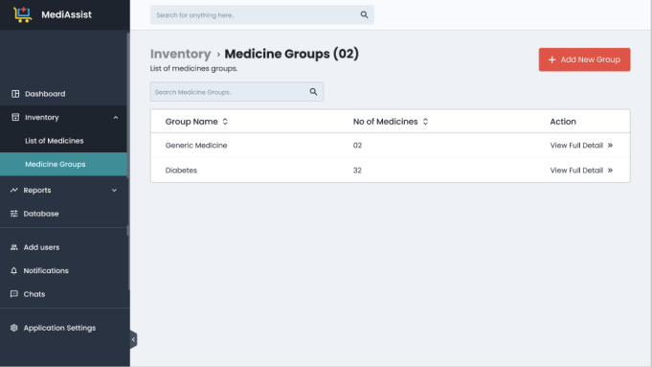Fig 4.2.11 Inventory (medicine group) | 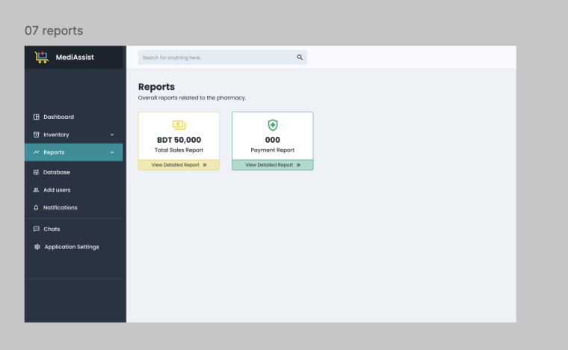  Fig: Admin Report
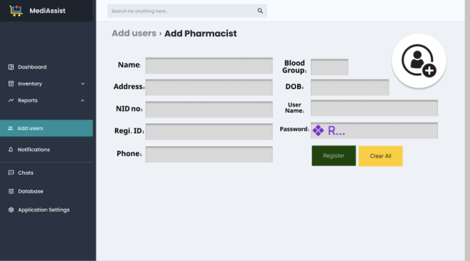  Fig 4.2.13 Add user (Pharmacist) | 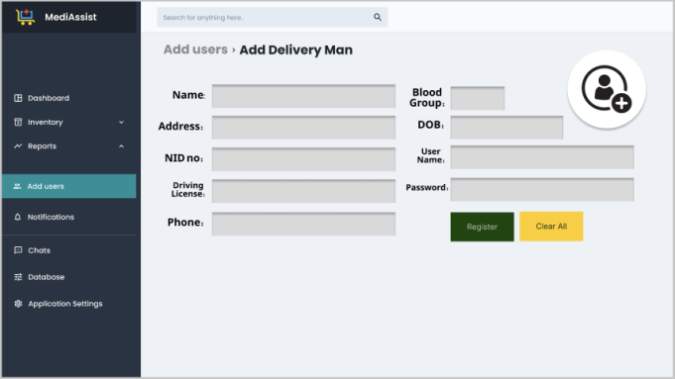Fig 4.2.13 Add user (Delivery man)
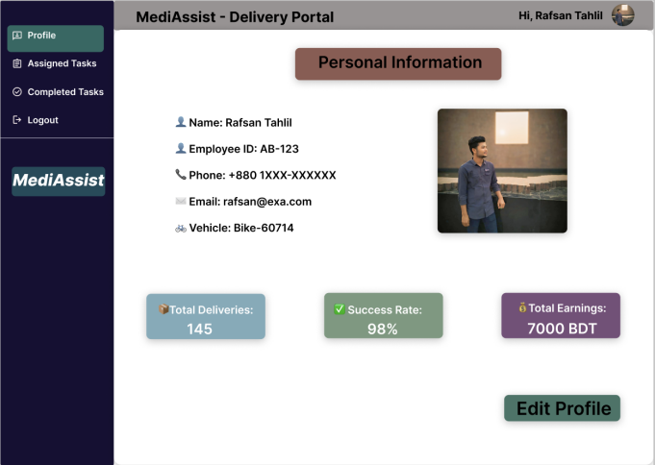Fig4.2. 14 Delivery man portal | 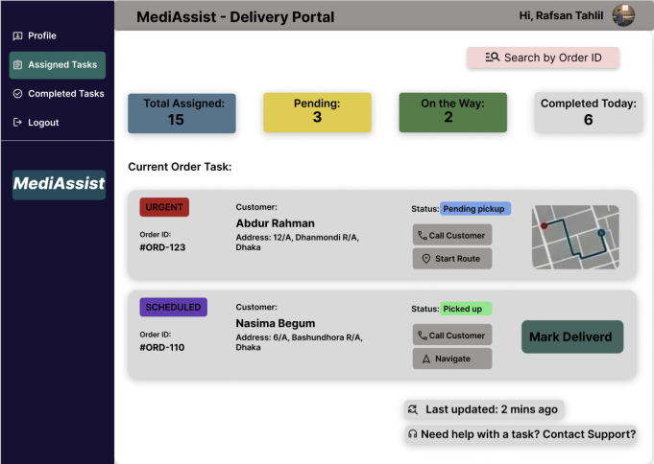Fig 4.2.15 Assinged task
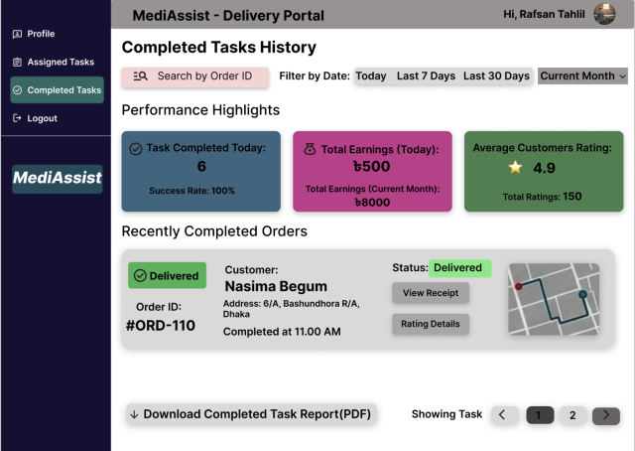
Fig 4.2.15 Completed task

5. GIT WORKFLOW
Repository link: https://github.com/dev-mehedi-github/Software-Eng_.git
- Contributor: Added by Mehedi hasan (22-48502-3)
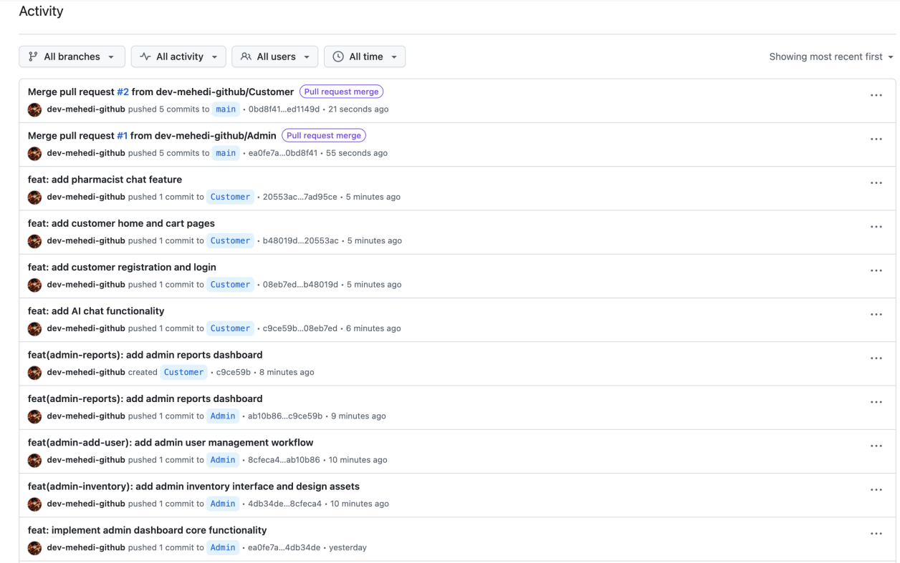

Repository link: https://github.com/RAFSAN-TAHLIL-RIFAT/MediAssist
- Contributor: Added by MD RAFSAN TAHLIL RIFAT (23-54948-3)

Trello board link:
https://trello.com/invite/b/69f4d2cd2566cf55300ef364/ATTIc156f6e04c79d5cef4091a6713d764dfB9F4C551/my-trello-board
- Final Trello Board
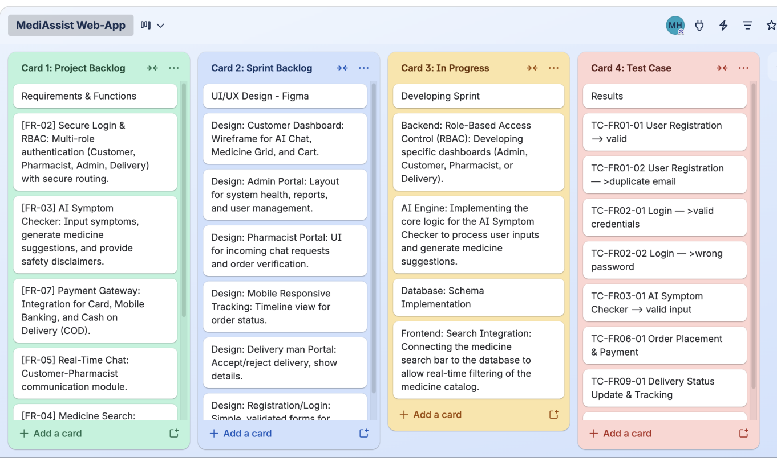

6. SOFTWARE TESTING
Test Cases: Mehedi Hasan (22-48502-3)
Test Case 1 of 2
Project Name: MediAssist(AI-Powered Online Pharmacy System) |  |  | Test Designed by: Mehedi hasan
Test Case ID: TC-FR01-01 |  |  | Test Designed date: 25/04/2026
Test Priority (Low, Medium, High): HIGH |  |  | Test Executed by: Mehedi hasan
Module Name: User Registration |  |  | Test Execution date: 30/04/2026
Test Title: Verify successful account registration with all valid mandatory fields
Description: Test that a new customer can create an account on the MediAssist platform by providing all required fields correctly.
Precondition: The user has not previously registered with the provided email address. The registration page is accessible.
Dependencies: Database connection is active. Email validation service is running.
Test Steps | Test Data | Expected Results |  | Actual Results | Status (Pass/Fail)
- Navigate to the MediAssist registration page.  - Enter a valid full name (e.g., John Doe).  - Enter a valid email address (e.g., john@email.com).  - Enter a strong password .  - Enter date of birth and phone number.  - Click the "Register" button. | Name: John Doe  Email: john@email.com  Password: Test1234  DOB: 01/01/2000 Phone: 01700000000 | Account is created successfully. User is redirected to the customer dashboard with a welcome message. |  | As expected | Pass

Test Case 2 of 2
Project Name: MediAssist(AI-Powered Online Pharmacy System) |  |  | Test Designed by: Mehedi hasan
Test Case ID: TC-FR01-02 |  |  | Test Designed date: 25/04/2026
Test Priority (Low, Medium, High): HIGH |  |  | Test Executed by: Mehedi hasan
Module Name: User Registration |  |  | Test Execution date: 30/04/2026
Test Title: Verify registration is rejected when a duplicate email address is used
Description: Test that the system prevents duplicate account creation by blocking registration with an already registered email.
Precondition: An account with email "john@email.com" already exists in the database.
Dependencies: Database connection is active.
Test Steps | Test Data | Expected Results |  | Actual Results | Status (Pass/Fail)
1. Navigate to the MediAssist registration page.  2. Enter the same email already registered (john@email.com).  3. Fill in all other mandatory fields with valid data.  4. Click the "Register" button. | Email: john@email.com (duplicate) Password: NewPass5678 Phone: 01800000000 | System displays an error message: "This email address is already registered. Please log in or use a different email." |  | As expected | Pass

Test Cases: MD Rafsan Tahlil Rifat
Test Case 1 of 2
Project Name: MediAssist (AI-Powered Online Pharmacy System) |  |  | Test Designed by:
Test Case ID: TC-FR02-01 |  |  | Test Designed date:
Test Priority (Low, Medium, High): High |  |  | Test Executed by: MD Rafsan Tahlil Rifat
Module Name: Login Session |  |  | Test Execution date: 02/05/2026
Test Title: Verify login with valid email and password
Description: Test login functionality with correct email and password
Precondition: User must have a registered account
Dependencies: Database connection active
Test Steps | Test Data | Expected Results |  | Actual Results | Status (Pass/Fail)
- Go to login page  - Enter valid email  3.Enter valid password  - Click login button | Email:  Password: | Login page open  User successfully login and redirected to dashboard |  | As expected  As expected | Pass  Pass
Test Case 1 of 2
Project Name: MediAssist (AI-Powered Online Pharmacy System) |  |  | Test Designed by:
Test Case ID: TC-FR02-02 |  |  | Test Designed date:
Test Priority (Low, Medium, High): Medium |  |  | Test Executed by: MD Rafsan Tahlil Rifat
Module Name: Login Session |  |  | Test Execution date: 03/05/2026
Test Title: Verify login with valid email and incorrect password
Description: Test login functionality with incorrect password
Precondition: User must have a registered account
Dependencies: Database connection active
Test Steps | Test Data | Expected Results |  | Actual Results | Status (Pass/Fail)
- Go to login page  - Enter valid email  3.Enter incorrect password  4.Click login button | Email:  Password: | Login page open  System shows error message and login fail |  | As expected,  As expected, | Pass  Pass

7. CONCLUSION
The main purpose of building a web app like MediAssist is to bring essential healthcare within reach for everyone in Bangladesh. Recognizing the daily struggles people face in finding verified medicines and reliable pharmacist advice, we built this all-in-one web application to simplify medicine procurement. The system addresses a critical real-world gap: the lack of accessible, verified, and convenient pharmacy services by integrating artificial intelligence, real-time communication, and secure multi-role access into a single cohesive platform.
Throughout the development life-cycle, the Scrum process model proved effective in organizing the team's efforts across six iterative sprints, ensuring incremental delivery of functional modules, including user authentication, AI symptom checking, medicine search, pharmacist–customer chat, order placement with payment gateway, delivery tracking, and an administrative control panel. The Requirements Traceability Matrix ensured every functional and non-functional requirement was mapped directly to a design component, code module, and test case, maintaining accountability across all phases.

